Available online at [www.sciencedirect.com](http://www.sciencedirect.com/)



AASRI Procedia 3 (2012) 624 – 629

2012 AASRI Conference on Modeling, Identification and Control

Self-Compacting Concrete Jacketing – Tests and Analysis

Constantin E. Chalioris*, Constantin N. Pourzitidis

*Democritus University of Thrace, Department of Civil Engineering, Xanthi 67100, GREECE*

**Abstract**

This study presents experimental and analytical results obtained from the application of a reinforced self-compacting concrete jacketing technique for the rehabilitation of shear damaged reinforced concrete beams. Three shear-dominated beams were initially subjected to monotonic four-point bending loading. The damaged beams were first restored using self-compacting concrete jackets that encased the bottom width and both vertical sides of the beams including small diameter steel bars and U-formed stirrups and then retested. The applied jacket was designed to increase the shear capacity of the initially tested beams and to alter their brittle failure mode to a more ductile one. Test results indicated that this jacketing technique is a promising rehabilitation method since the strength and the overall performance of the jacketed beams was ameliorated with respect to the initial specimens. Analytical results of the flexural and the shear capacity of the tested beams are also presented. Comparisons between test data and predicted strength values showed a good agreement.

© 2012 The Authors. Published by Elsevier B.V. Open access under [CC BY-NC-ND license.](http://creativecommons.org/licenses/by-nc-nd/3.0/)

© 2012 Published by Elsevier B.V. Selection and/or peer review under responsibility of American Applied Science Research Institute

Selection and/or peer review under responsibility of American Applied Science Research Institute

*Keywords:* Self-compacting concrete; reinforced concrete; jacket; tests; shear; flexure; damage; beam; analysis

# Introduction

Jacketing is a well-known rehabilitation technique of poorly detailed or damaged reinforced concrete members that provides increased strength, stiffness and overall enhancement of the structural performance [1]. Jackets constructed by conventional cast-in-place concrete [2], premixed, non-shrink, flowable, rapid and high-strength cement-based mortar [3], shotcrete [1, 4], Textile-Reinforced-Mortars [5] and Fibre-Reinforced- Polymers [6] have been examined in existing inadequate or damaged structural elements.

* Corresponding author. Tel./fax: +302541079632

*E-mail address:* [chaliori@civil.duth.gr](mailto:chaliori@civil.duth.gr)

2212-6716 © 2012 The Authors. Published by Elsevier B.V. Open access under [CC BY-NC-ND license.](http://creativecommons.org/licenses/by-nc-nd/3.0/) Selection and/or peer review under responsibility of American Applied Science Research Institute doi:10.1016/j.aasri.2012.11.099



**Nomenclature**

*b*, *d* width and effective depth of the cross-section of the beam, respectively, mm

*a* shear span of the tested beams equal to 600 mm

*x*, *c* depth of neutral axis in flexural and in shear analysis, respectively, mm

*fc* , *fct*mean cylinder compressive and splitting tensile strength of concrete, respectively, MPa

*fyw*

*l* ,

*d'*

yield strength of the steel stirrups equal to 255 MPa

*l*

ratio of the tension and compression steel longitudinal reinforcement, respectively, %

*Vu*

concrete centroid cover of the compression steel bars of the initially tested beams equal to 25 mm size effect coefficient in shear analysis that equals to: 1.08 = 1.2 – 0.2*a* 0.65 (*a* = 0.6 m)

ultimate shear capacity, N (1 kN = 1000 N)

*MVu* bending moment corresponding to the ultimate shear capacity (= *aVu* ), N-mm (1 kN-m = 106 N-mm)

*MR,u* ultimate flexural capacity (ultimate bending moment resistance), N-mm (1 kN-m = 106 N-mm)

*Fsi* force of the steel bars of the initial beam, N (1 kN = 1000 N)

*Fsj* force of the steel bars of the jacket, N (1 kN = 1000 N)

Recently, the rehabilitation of flexural damaged reinforced concrete beams using self-compacting concrete jackets has been experimentally investigated [7]. Test results indicated that the flexural capacity of the jacketed beams was ameliorated with respect to the capacity of the initial specimens. The application of this self-compacting concrete jacketing technique is extended herein to shear-dominated beams.

# Experimental research

* 1. *Initially tested beams*

Three reinforced concrete beams with total length 1.6 m and cross-sectional dimensions 125/200 mm have been constructed. Geometrical and reinforcement characteristics of these specimens are displayed in Figure 1 (beams A1, A2 and A3). The mean compressive and tensile strength of the commonly used concrete of these initial specimens was 24.8 MPa and 2.1 MPa, respectively, as measured from uniaxial compression and splitting tests of six cylinders per testing, respectively. The measured tensile yield strength of the deformed longitudinal steel bars and the mild steel stirrups was 570 MPa and 255 MPa, respectively, whereas their ultimate tensile strength was found to be 770 MPa and 357 MPa, respectively. Beams were designed in order to demonstrate shear failure mode and for this reason inadequate amount of stirrups has been provided.

* 1. *Jacketed beams*

After the initial loading, the shear damaged beams were rehabilitated using reinforced jackets made of self- compacting concrete. The thickness of the jackets was 25 mm. Jackets encased the bottom width and both vertical sides of the damaged beams (U-formed jacketing). The steel reinforcement of the jackets consists of small diameter 5 mild steel straight bars and U-formed stirrups with tensile strength at yield 255 MPa and at ultimate 357 MPa. The geometrical and reinforcement characteristics of the jacketed beams are shown in

Figure 1 (beams A1-J, A2-J and A3-J). The objective of the self-compacting concrete jacketing design was twofold; first to fully restore the shear damaged beams and second to increase the amount of the provided reinforcement, focused on the shear reinforcement, in order to enhance the performance of the jacketed beams with respect to the initially tested beams and, potentially, to alter their failure mode to a more ductile one.

Initially tested beams sustained severe shear damages, spalling of concrete cover and intense diagonal cracking. All loose concrete fragments were completely removed and the missing concrete parts reconstructed by jacketing reformed and re-casted by self-compacting concrete. No special roughening of the surface of the damaged beams was performed prior jacketing construction. L-shaped mild steel dowels with 5 mm diameter were installed in the vertical sides of the initial beams in order to support the longitudinal bars of the jacket. Dowels were bonded by injected epoxy resin into 7 mm holes that were drilled before. The amount of the provided dowels was rather low; every side bar of the jacket had dowels 5 per 150 mm. Steel bars, stirrups and dowels of the jacketed beams were all welded together.

**A1**

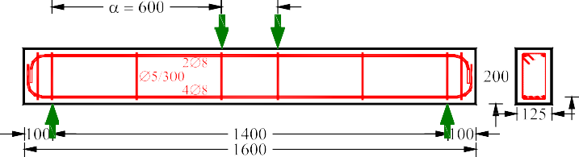

**A1-J**

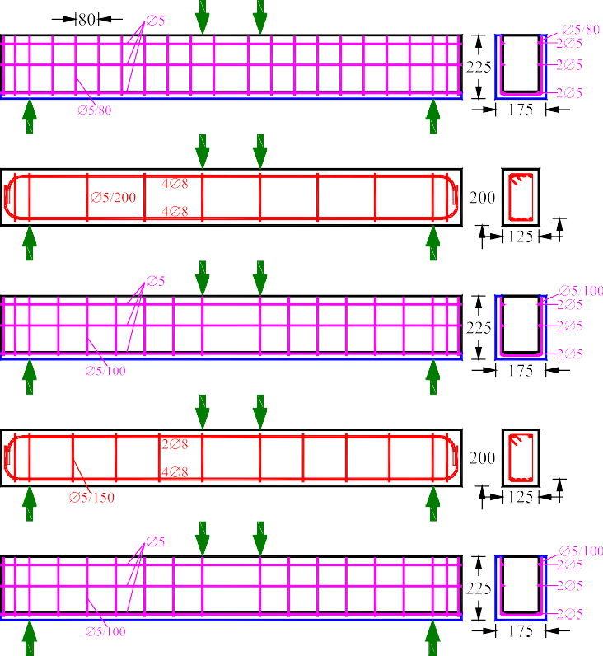

**A2 A2-J**

**A3 A3-J**

Fig. 1. Geometry, steel reinforcement arrangement and loading scheme of the initially tested and the jacketed beams

Cast-in-place self-compacting concrete with the mix proportions shown in Table 1 was used. The cement of the mixture contained 305 kg of CEM IV (W-P)/B 32.5 N and 51 kg of CEM II 42.5 N. Fine and coarse aggregates with maximum diameter 8 mm were also used. Further, superplasticizer (Glenium 21), retarder (Pozzolith 134 CF) and viscosity modifying admixture (VMA) were added in order to bring the required water reduction and fluidity, and to increase cohesion and segregation resistance [8]. The measured mean self- compacting concrete compressive and splitting tensile strength was 40.1 MPa and 3.3 MPa, respectively. After jacketing formwork stripping the final result was generally good and the limited superficial imperfections observed were fixed using high-strength, low-shrinkage and rapid-hardening cement paste [9].

Table 1. Mix proportions for casting one cubic meter of the used self-compacting concrete of the jackets

|  |  |  |  |  |  |  |  |
| --- | --- | --- | --- | --- | --- | --- | --- |
| Cement | Water | Fine aggregate | Coarse aggregate | Filler | Superplasticizer | Retarder | VMA |
| 1 | 0.54 | 2.48 | 2.25 | 0.28 | 0.0335 | 0.0032 | 0.0012 |

* 1. *Test setup*

All beams were tested in monotonically increasing loading up to total failure. Beams were edge-supported on roller supports using a rigid laboratory frame. The loading was applied using a steel spreader beam in two symmetrical points in the mid-span of the beams adopting a four-point bending scheme with a shear span of 600 mm (see also Fig. 1). The ratio of the span to the effective depth of the initially tested and the jacketed beams was 3.43 and 2.93, respectively. Loading was imposed by a pinned-end actuator and measured by a load cell with an accuracy of 0.05 kN. The net mid-span deflections of the beams were recorded by three LVDTs with 0.01 mm accuracy; one was placed in the mid-span of the beam and two in the supports. Measurements of load and corresponding deflections were read and recorded continuously during the tests.

* 1. *Test results*

The experimental behavior of the initially tested and the jacketed beams is presented in Figure 2 in terms of bending moment versus mid-span deflection curves. An increase of the loading bearing capacity of the jacketed beams with respect to the corresponding initial beams can be observed. Further, the cracking patterns at failure of the beams are displayed in Figure 3. All initially tested beams exhibited diagonal cracking and typical brittle shear response whereas all jacketed beams showed pure flexural failure and ductile behavior.

30

30

30

25

Calculated flexural 25

strength

Calculated flexural

strength

25

Calculated flexural

strength

20

20

20

Calculated shear strength

Calculated shear strength

15

Calculated shear strength

Jacket (A1-J) Initial (A1)

15

15

10

10

Jacket (A2-J) Initial (A2)

10

Jacket (A3-J) Initial (A3)

5 5 5

0

0

0

0 20 40 60 80 100 120 0 20 40 60 80 100 120 0 20 40 60 80 100 120

Midspan deflection (mm) Midspan deflection (mm) Midspan deflection (mm)

Bending moment (kN-m)

Bending moment (kN-m)

Bending moment (kN-m)

Fig. 2. Experimental behavior of the initially tested and the jacketed beams and predicted values of ultimate flexural and shear capacities

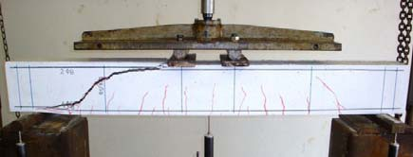 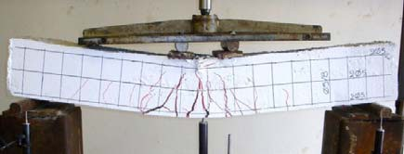

Initially tested beam A1 Jacketed beam A1-J

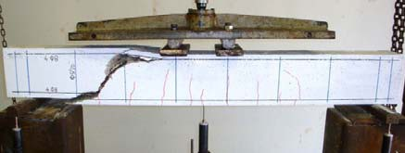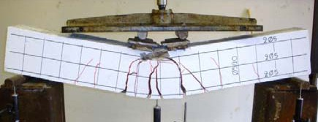

Initially tested beam A2 Jacketed beam A2-J

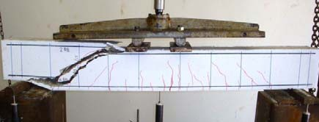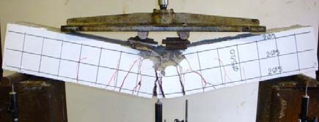

Initially tested beam A3 Jacketed beam A3-J

Fig. 3. Cracking patterns at failure of the beams

# Analysis

The ultimate shear capacity of the initially tested shear-dominated beams can be calculated using the following theoretical expression [10]:



*Vu*

*c*

*d*

*fct*

0.5 

0.25 *a*

*d*

*w f yw*

*bd * *MVu*

 *aVu*

*(1)*

2  *d d*

*c*

*d*



*l*

*fc*

*c*

*d*



*l*

 600  *l*

600  *l * 0

*fc*

*(2)*

Further, the calculation of the ultimate flexural capacity can be carried out in reference to the strain and stress distributions shown in Figure 4 and using the following expression:



*MR*,*u*

 *Fsj*1 205

0.4*x*

*Fsj* 2 105

0.4*x*

*Fsj*3 30

0.4*x*

*Fsi*1 175

0.4*x*

*Fsi* 2 25

0.4*x*

*(3)*

The calculated values of the ultimate shear capacity of the initially tested beams and the flexural capacity of the jacketed beams are presented in Figure 3 and compared with the corresponding experimental data.

75

30

175

205

Fig. 4. Internal forces, strain and stress distributions at cross-section of the jacketed beams

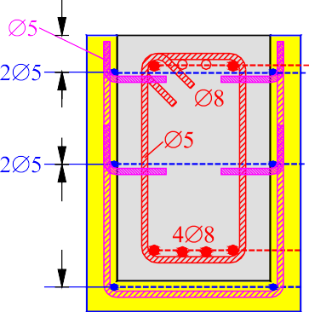

***c***

***sj3***

***Fsi2 Fsj3***

***Fsj2***

***Fc+Fscc***

**0.8*x***

***sj2***

***si1***

***sj1***

***Fsi1 Fsj1***

25

125

25

***si2***

**Self-compacting concrete jacket**

***x***

225

200

25

100

# Concluding remarks

The examined self-compacting concrete jacketing seems to be an effective rehabilitation technique to shear damaged reinforced concrete beams. The load bearing capacity and the overall structural performance of the jacketed beams was ameliorated with respect to the initially tested specimens. A good agreement between the predicted results and the test data of this study can be observed.

# References

1. Bousias SN, Biskinis D, Fardis MN, Spathis A-L. Strength, stiffness, and cyclic deformation capacity of concrete jacketed members. ACI Struct J 2007;104(5):521-31.
2. Vandoros KG, Dritsos SE. Concrete jacket construction detail effectiveness when strengthening RC columns. Constr & Build Mater 2008;22(3):264-66.
3. Karayannis CG, Chalioris CE, Sirkelis GM. Local retrofit of exterior RC beam-column joints using thin RC jackets - An experimental study. Earthq Eng & Struct Dyn 2008;37(5):727-46.
4. Tsonos AG. Performance enhancement of R/C building columns and beam-column joints through shotcrete jacketing. Eng Struct 2010;32(3):726-40.
5. Triantafillou TC, Papanicolaou CG. Shear strengthening of reinforced concrete members with textile reinforced mortar (TRM) jackets. Mater & Struct 2006;39(285):93-103.
6. Karayannis CG, Sirkelis GM. Strengthening and rehabilitation of RC beam-column joints using carbon- FRP jacketing and epoxy resin injection. Earthq Eng & Struct Dyn 2008;37(5):769-90.
7. Chalioris CE, Pourzitidis CN, Papadopoulos CP, Fotis D. Flexural rehabilitation of RC beams using self- compacting concrete jacketing. Proc 2nd Int Conf Civil Eng & Build Mater, Hong Kong, 2012, ID 257.
8. Georgiadis AS, Sideris KK, Anagnostopoulos NS. Properties of SCC produced with limestone filler or viscosity modifying admixture. J Mater Civil Eng 2010;22(4):352-60.
9. Karayannis CG, Chalioris CE, Sideris KK. Effectiveness of RC beam-column connection repairing using epoxy resin injections. J Earthq Eng 1998;2(2):217-40.
10. Zararis PD. Shear strength and minimum shear reinforcement of reinforced concrete slender beams. ACI Struct J 2003;100(2):203-14.